Zewail City of Science, Technology, and Innovation  University of Science and Technology  School of Computational Sciences and Artificial Intelligence  CSAI 202 - Fall 2023 | Team 13
Introduction to Database Systems
<University System>

Team Number: 13

Team Members:
Name: <Ali Adel> ID: <202202078>
Name: <Abdulrahman Omar> ID: <202202254>
Name: <Mostafa Hisham Ahmed> ID: <202201998>
Name: <Omar Eldesoukey> ID: <202202155>

Contact info:
s-abdalrahman.mohammed@zewailcity.edu.eg

<10/20/2033>

Final Schema: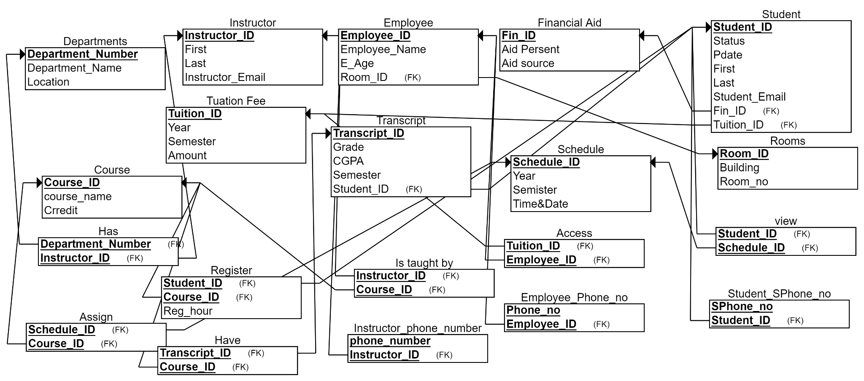

Final ER Diagram:

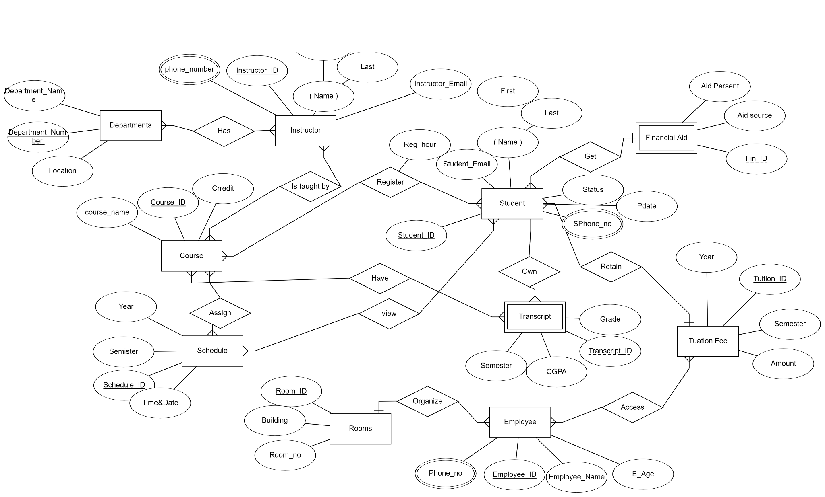

SQL:

https://docs.google.com/document/d/1E3AXDU6XblfeZiHZolzjchgx9OxoSgvy2MvVGgfWYDw/edit?usp=sharing

CREATE TABLE Departments (
Department_Number INT NOT NULL IDENTITY(1,1),
Department_Name NVARCHAR(255) NOT NULL,
Location INT NOT NULL,
PRIMARY KEY (Department_Number)
);
CREATE TABLE Rooms (
Room_ID INT NOT NULL IDENTITY(1,1),
Building NVARCHAR(255) NOT NULL,
Room_No INT NOT NULL,
PRIMARY KEY (Room_ID)
);
CREATE TABLE Employees (
Employee_ID INT NOT NULL IDENTITY(1,1),
First_Name NVARCHAR(255) NOT NULL,
Last_Name NVARCHAR(255) NOT NULL,
E_Age INT NOT NULL,
Pdate DATE NOT NULL,
PRIMARY KEY (Employee_ID)
);
CREATE TABLE Instructor (
Instructor_ID INT NOT NULL IDENTITY(1,1),
First_Name NVARCHAR(255) NOT NULL,
Last_Name NVARCHAR(255) NOT NULL,
Instructor_Email NVARCHAR(255) NOT NULL,
PRIMARY KEY (Instructor_ID)
);
CREATE TABLE Students (
Student_ID INT NOT NULL IDENTITY(1,1),
First_Name NVARCHAR(255) NOT NULL,
Last_Name NVARCHAR(255) NOT NULL,
Student_Email NVARCHAR(255) NOT NULL,
Fin_ID INT,
PRIMARY KEY (Student_ID)
);
CREATE TABLE Financial_Aid (
Fin_ID INT NOT NULL IDENTITY(1,1),
Student_ID INT NOT NULL,
Aid_Percent DECIMAL(5,2) NOT NULL,
Aid_Source NVARCHAR(255) NOT NULL,
PRIMARY KEY (Fin_ID),
FOREIGN KEY (Student_ID) REFERENCES Students(Student_ID)
);
CREATE TABLE Course (
Course_ID INT NOT NULL IDENTITY(1,1),
Course_Name NVARCHAR(255) NOT NULL,
Credit INT NOT NULL,
PRIMARY KEY (Course_ID)
);
CREATE TABLE Tuition_Fee (
Tuition_ID INT NOT NULL IDENTITY(1,1),
Year INT NOT NULL,
Semester NVARCHAR(255) NOT NULL,
Amount DECIMAL(10, 2) NOT NULL,
PRIMARY KEY (Tuition_ID)
);
CREATE TABLE Schedule (
Schedule_ID INT NOT NULL IDENTITY(1,1),
Course_ID INT NOT NULL,
Instructor_ID INT NOT NULL,
Year INT NOT NULL,
Semester NVARCHAR(255) NOT NULL,
Time_and_Date DATETIME NOT NULL,
Room_ID INT,
PRIMARY KEY (Schedule_ID),
FOREIGN KEY (Course_ID) REFERENCES Course(Course_ID),
FOREIGN KEY (Instructor_ID) REFERENCES Instructor(Instructor_ID),
FOREIGN KEY (Room_ID) REFERENCES Rooms(Room_ID)
);
CREATE TABLE Transcripts (
Transcript_ID INT NOT NULL IDENTITY(1,1),
Student_ID INT NOT NULL,
Course_ID INT NOT NULL,
Grade NVARCHAR(255) NOT NULL,
Schedule_ID INT NOT NULL,
PRIMARY KEY (Transcript_ID),
FOREIGN KEY (Student_ID) REFERENCES Students(Student_ID),
FOREIGN KEY (Course_ID) REFERENCES Course(Course_ID),
FOREIGN KEY (Schedule_ID) REFERENCES Schedule(Schedule_ID)
);
CREATE TABLE Register (
Student_ID INT NOT NULL,
Course_ID INT NOT NULL,
Reg_Hour INT NOT NULL,
Is_Taught_By INT NOT NULL,
Employee_ID INT NOT NULL,
PRIMARY KEY (Student_ID, Course_ID),
FOREIGN KEY (Student_ID) REFERENCES Students(Student_ID),
FOREIGN KEY (Course_ID) REFERENCES Course(Course_ID),
FOREIGN KEY (Employee_ID) REFERENCES Employees(Employee_ID)
);
CREATE TABLE Has_Access (
Student_ID INT NOT NULL,
Tuition_ID INT NOT NULL,
Schedule_ID INT NOT NULL,
View_Status CHAR(1) NOT NULL CHECK (View_Status IN ('T', 'F')),
PRIMARY KEY (Student_ID, Tuition_ID, Schedule_ID),
FOREIGN KEY (Student_ID) REFERENCES Students(Student_ID),
FOREIGN KEY (Tuition_ID) REFERENCES Tuition_Fee(Tuition_ID),
FOREIGN KEY (Schedule_ID) REFERENCES Schedule(Schedule_ID)
);
CREATE TABLE Tuition (
Tuition_ID INT NOT NULL IDENTITY(1,1),
Tuition_Fee DECIMAL(10, 2) NOT NULL,
PRIMARY KEY (Tuition_ID)
);
CREATE TABLE Instructor_Phone_Number (
Phone_Number INT NOT NULL,
Instructor_ID INT NOT NULL,
PRIMARY KEY (Phone_Number, Instructor_ID),
FOREIGN KEY (Instructor_ID) REFERENCES Instructor(Instructor_ID)
);
CREATE TABLE Employee_Phone_Number (
Phone_Number INT NOT NULL,
Employee_ID INT NOT NULL,
PRIMARY KEY (Phone_Number, Employee_ID),
FOREIGN KEY (Employee_ID) REFERENCES Employees(Employee_ID)
);
CREATE TABLE Student_Phone_Number (
Phone_Number INT NOT NULL,
Student_ID INT NOT NULL,
PRIMARY KEY (Phone_Number, Student_ID),
FOREIGN KEY (Student_ID) REFERENCES Students(Student_ID)
);

Ali adel

